**Practical 1**

**Aim:**

**Starting Raspbian OS, Familiarising with Raspberry Pi Components and interface, Connecting to ethernet, Monitor, USB.**

**Accessories needed:**

1. **Raspberry Pi 3**

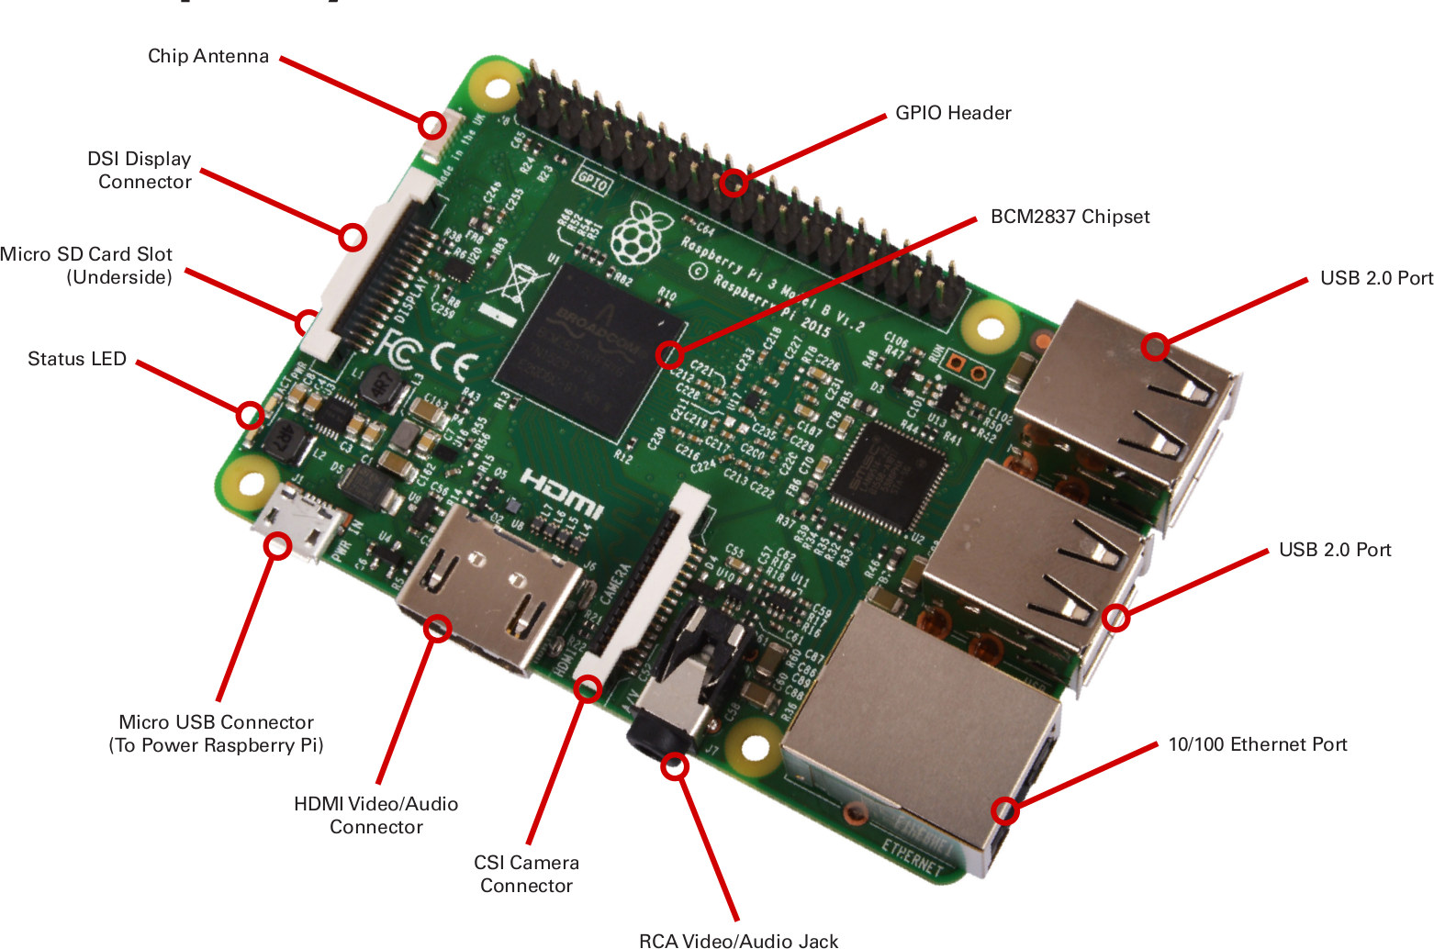

1. **A power supply**
2. **An HDMI cable**.
3. **A USB mouse and keyboard**.
4. **An SD memory card**.
5. **An SD memory card reader**.
6. **Internet connection. (Ethernet or wireless)**

**Steps to make bootable SD card for Raspberry Pi (raspbian stretch)**

**1: Get raspbian OS on your micro SD card:**

1. Download raspbian from raspberrpi.org and click download and then click on Raspbian (select Raspbian Strech with desktop file.) mostly as zip file.

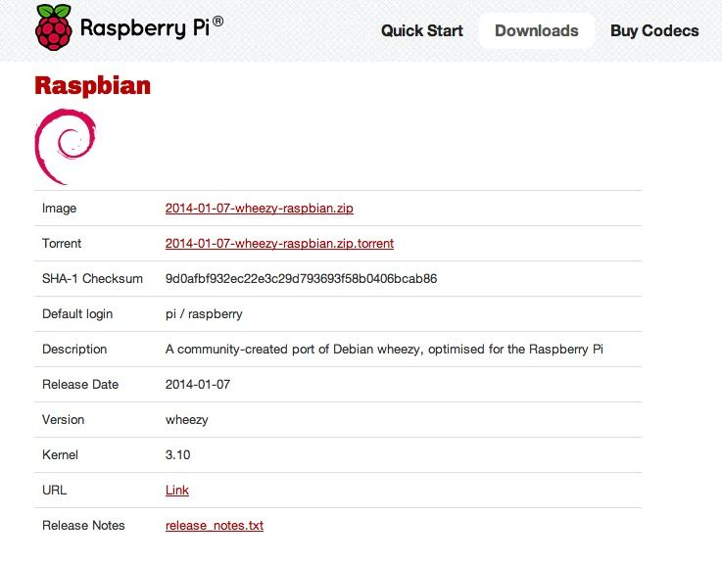

1. Unzip file to find a disc image.
2. Format new SD card using SD Formatter tool.
3. You need to install BalenaEtcher/Win32DiskImager tool to write image to SD card.
4. In Balena Etcher/Win32DiskImager tool select image file and click Write button.

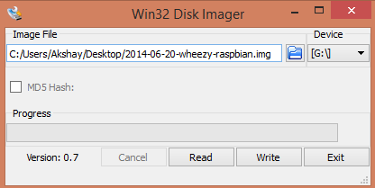

1. Once it is written your card name will change into boot.
2. Now can insert this card in your Raspberry Pi.

**2: Configuring Pi:**

Raspberry Pi comes with a default user name and password and so always use it whenever it is being asked. The credentials are:

login: pi

password: raspberry

When the Pi has been booted for the first time, a configuration screen called the "Setup Options" should appear and it will look like the image below.

We can open this window with

sudo raspi-config

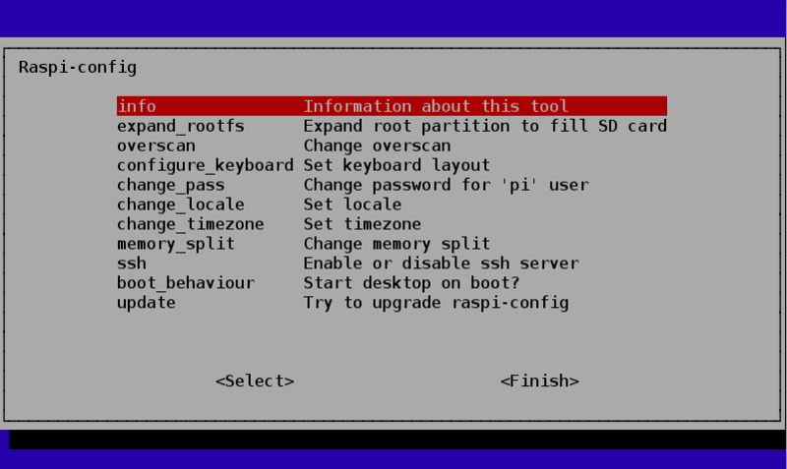

* change_locale – For non-English speakers, you can select which locales should be available on the system and which should be the default for the operating system.

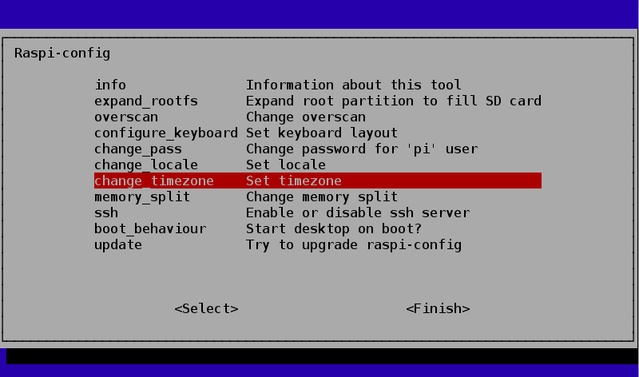

first select the Geographic Area as **ASIA**

then the Timezone within that area as **Kolkata.**

**Alternate Option:**

**Using the Raspberry Pi Configuration tool**

Presently, the Raspberry Pi Configuration tool displays four tabs:

* System. Options to expand the file system and change password and hostname sit alongside various login choices.
* Interfaces. Support for the various hardware and software features, such as Camera Module, SSH, and VNC.
* Performance. Overclocking and GPU memory options can improve the performance of a Raspberry Pi.
* Localisation Set up an international keyboard, global WiFi options, and adjust the locale and time zone.

### Interfaces Tab

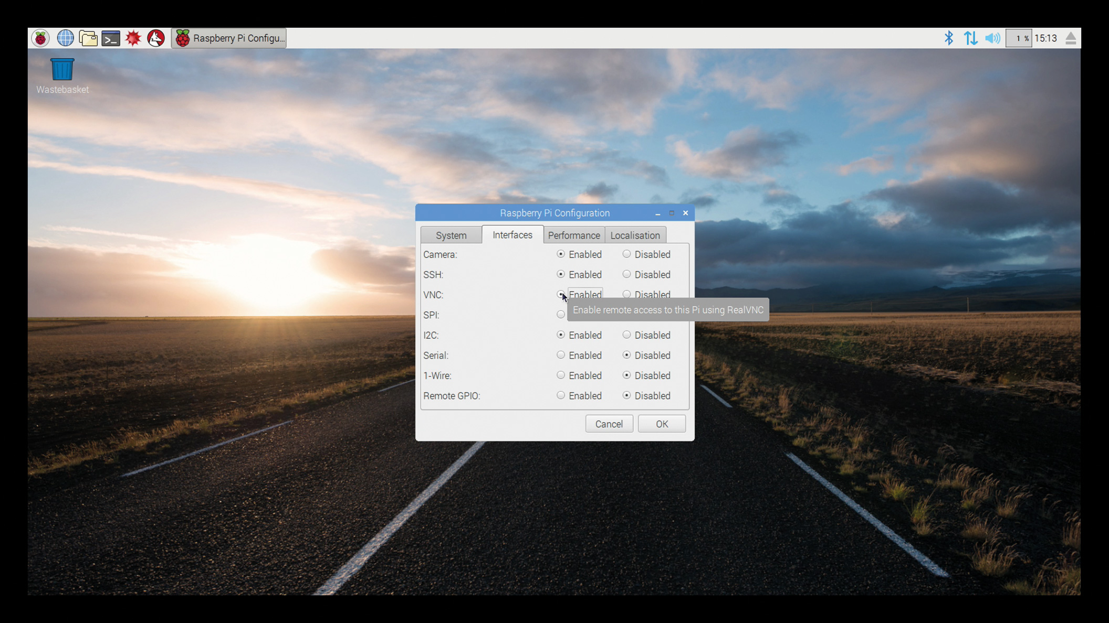

### Localisation Tab

### Set Locale option

### Image result for raspberry pi configuration tool localization

### Set Timezone option

### Image result for raspberry pi configuration tool localization

### Select location as Kolkata

### Set keyboard option

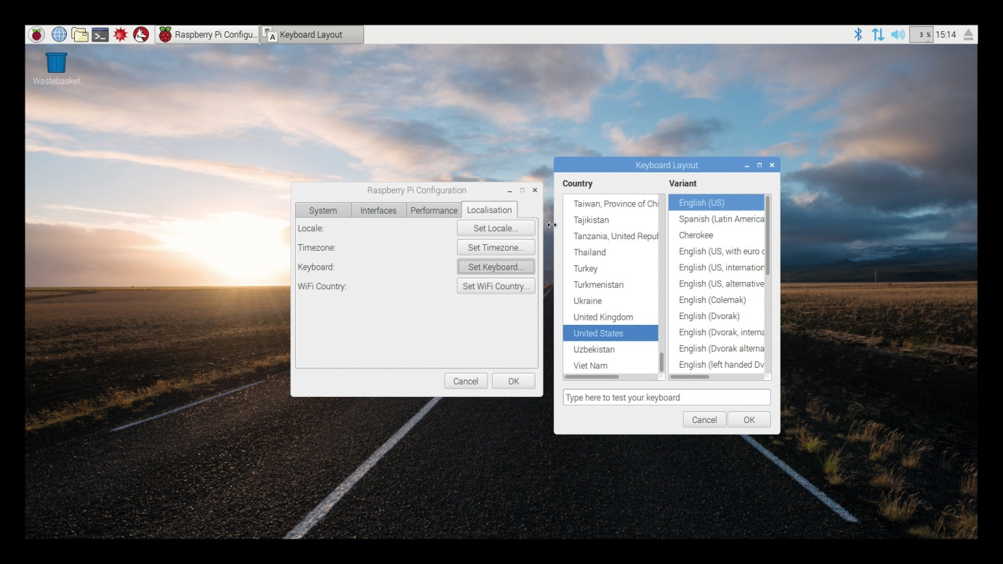

1. **Set WiFi country option**

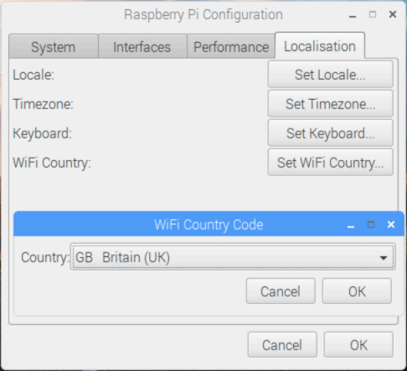

**Select INDIA here**

**Linux commands**

**File system**

1. **ls:** The ls command lists the content of the current directory
2. **cd:** Using cd changes the current directory to the one specified. You can use relative (i.e. cd directoryA) or absolute (i.e. cd /home/pi/directoryA) paths.
3. **pwd:** The pwd command displays the name of the present working directory entering pwd willoutput something like /home/pi.
4. **mkdir:** You can use mkdir to create a new directory, e.g. mkdir newDir would create the directory newDir in the present working directory.
5. **rmdir:** To remove empty directories, use rmdir. So, for example, rmdir oldDir will remove the directory oldDir only if it is empty.
6. **rm:** The command rm removes the specified file (or recursively from a directory when used with -r).
7. **cp:** Using cp makes a copy of a file and places it at the specified.
8. **ssh:** SSH denotes the secure shell. Connect to another computer using an encrypted network connection.
9. **scp:** The scp command copies a file from one computer to another using ssh.
10. **sudo:** The sudo command enables you to run a command as a superuser, or another user. Use sudo -s for a superuser shell. For more details see Root user / sudo
11. **dd:** The dd command copies a file converting the file as specified. It is often used to copy an entire disk to a single file or back again.
12. **df:** Use df to display the disk space available and used on the mounted filesystems. Use df -h to see the output in a human-readable format using M for MBs rather than showing number of bytes.
13. **unzip:** The unzip command extracts the files from a compressed zip file.
14. **wget:** Download a file from the web directly to the computer with wget. So wget https://www.raspberrypi.org/documentation/linux/usage/commands.mdwill download this file to your computer as commands.md
15. **grep:** Use grep to search inside files for certain search patterns.
16. **awk:** awk is a programming language useful for searching and manipulating text files.
17. **find:** The find command searches a directory and subdirectories for files matching certain patterns.

**Networking**

1. **ping:** The ping utility is usually used to check if communication can be made with another host. It can be used with default settings by just specifying a hostname (e.g., ping raspberrypi.org) or an IP address (e.g., ping 8.8.8.8).
2. **nmap:** nmap is a network exploration and scanning tool. It can return port and OS information about a host or a range of hosts. Running just nmap will display the options available as well as example usage.
3. **hostname:** The hostname command displays the current hostname of the system.
4. **ifconfig:** Use ifconfig to display the network configuration details for the interfaces on the current system when run without any arguments (i.e., ifconfig). By supplying the command with the name of an interface (e.g., eth0 or lo) you can then alter the configuration. Check the manual page for more details.